**Creating and Managing Contracts**

Creating a Contract

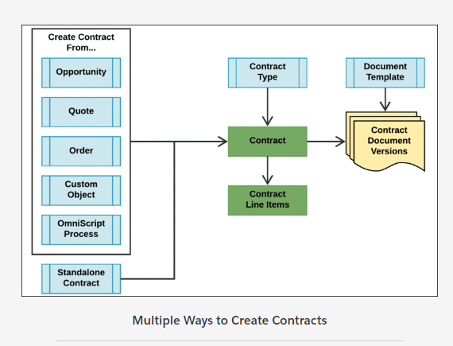

You can create a contract from an opportunity, quote, order, custom object, or an OmniScript process.

You can also create standalone contracts such as frame agreements.

A contract belongs to a predefined contract type.

CLM creates contract line items with the contract if you create the contract from an opportunity, quote or order. If you create the contract from a custom object, you need to create the line items manually.

The newly-created contract includes a contract document record, which represents the first version of the contract. You can apply a document template, and create more versions of the contract document as you customize it.

Contract Document Operations

Open the Documents tab to view the contract document versions and their attached files:

* **Reminder:** The contract document generation process involves merging contract data with its template definition, and replacing all tokens in the template.
* When you convert an opportunity, quote, or order into a contract, it's possible to auto-apply the most appropriate contract template when you generate the document draft. You can change the template if needed

You can perform various contract document operations on each contract document version. These operations are OmniStudio Actions. The Contract State Model controls the available operations for each version, and who can perform them and when.

Viewing the Online Contract Document

Click **View** on any document version (active or inactive) to preview the contract document in HTML format. The Preview page shows you the latest data for that version. On this page, you can download a PDF or Word file of the document, and you can attach PDF or Word files. Click **Go Back to Contract** when you're finished.

Generating a New Contract Document

Click **Check Out to Generate** to generate a new contract document for an already-generated document. You can do this if you want to select a different document template.  
  
When you check the document back in, the newly-generated version of the document reflects changes to the contract data and template. The Check In operation can directly generate a MS Word/PDF of the contract document, and attach it to the version. You can also separately download the MS Word or PDF if needed.

# Contract Negotiation

During contract customization and negotiation, you can redline specific changes in the online contract document, which then go through an internal approval process.

If your customer needs to make changes to the contract, you can send them a Word document. After the customer makes their changes and returns the document, you can reconcile it with the online contract document or simply attach it to the contract record if preferred.

When a contract document has more than one version, you can perform a side-by-side comparison of the versions online.

Collaborative Contract Redlining

Your requirements will dictate what kind of approval processes you enforce for your contracts. For example, you may not want to enforce additional approvals before you send standard contract documents to a customer for eSignature because you've generated the document from a standard template, which is pre-approved by the template author/legal team. You can manage the CLM lifecycle to suit this requirement, so that you can send a document for eSigature as long as it's not modified.

When you need to change contract specifics such as clauses or other types of data, you can send the customized document through a collaborative redlining process:

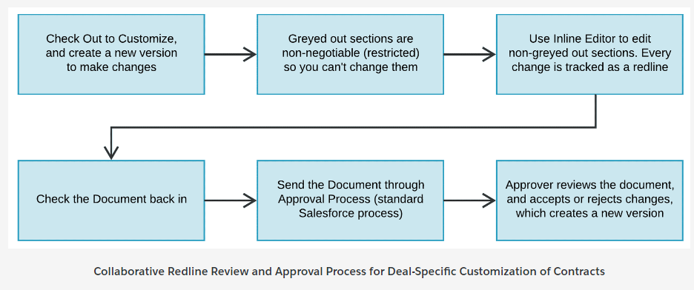

Word Document Reconciliation

As contract redlining is an internal process only, you must send a Word document to the customer if the customer needs to be involved in the contract negotiation and redlining.

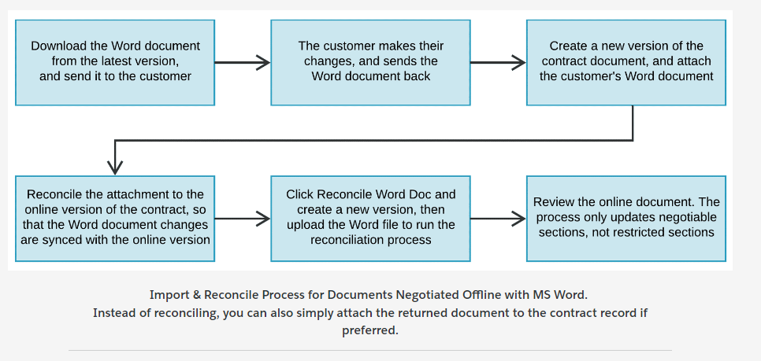

Comparing Contract Document Versions

**When a contract has multiple versions, how can you compare them?**  
The Compare Versions button is available on every contract document version, so you can compare two versions of a contract document side-by-side.

eSignatures with DocuSign

CLM integrates with DocuSign to enable eSignatures. DocuSign manages the eSignature flow.

When the contract document is finalized and approved, email it to the appropriate recipients for their signature.

After all signatures are done, DocuSign returns the signed document, which can be automatically attached back to the latest version of the contract.

After all parties have signed, the contract is Approved and goes into effect.

# Contract Renewals and Amendments

You can renew or extend, amend, and terminate contracts. CLM allows you to generate renewal notifications before a contract expires, and automatically create renewal opportunities, quotes, or orders.

You can implement processes with OmniScripts. However, as different organizations have different business rules for amending, terminating, and renewing contracts, the provided Omniscripts are only samples that you can refer to and use as a starting point.

**Renewing or Extending a Contract**

CLM can automatically generate renewal notifications before contract expiration. You can set a contract for automatic renewal, and set renewal notification options.

If the contract is not flagged for automatic renewal, use the Renew Contract action to renew an activated contract manually.

**Amending a Contract**

Use the Amend Contract action to make changes to the contract after it has been signed and activated.

**Terminating a Contract**

Use the Terminate Contract action to terminate the entire contract or some of its lines.

# Contract Types

Contract types allow you to manage different types of contracts within one org.  
You can configure each contract type to provide access to the appropriate users, define contract stages and approval processes, define specific clauses and templates, and specify parameters such as DocuSign reminders.

Salesforce Industries provides a default contract type, which we recommend you clone when you want to create new contract types.

Contract Type Examples

You can create a different contract type for each line of a company's business and configure the appropriate access and options. You can specify a contract’s purpose; for example, whether it's a sales contract, nondisclosure agreement, or partnership agreement.

Contract Records, Types, State Models, and Lifecycles

You can have different types of contracts with different state models, which in turn determine the contract lifecycles (see next lesson). A contract record can belong to only one contract type.

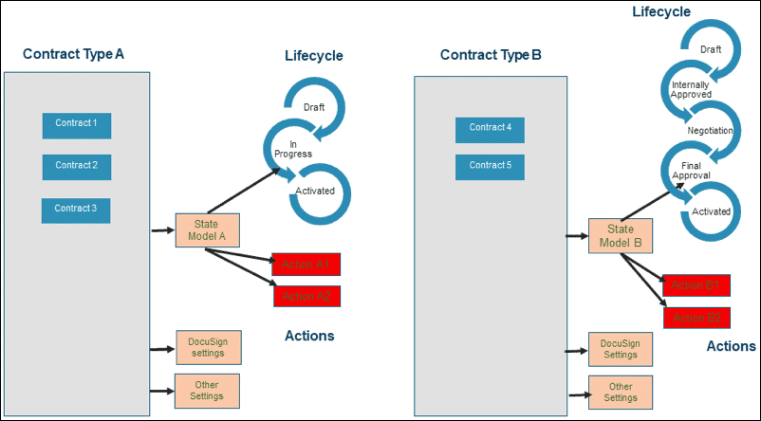

Contract Type Settings

You can configure various settings for a contract type so that you can control the behavior of the contracts belonging to the contract type. CLM provides a default contract type, which you can clone to create new contract types.

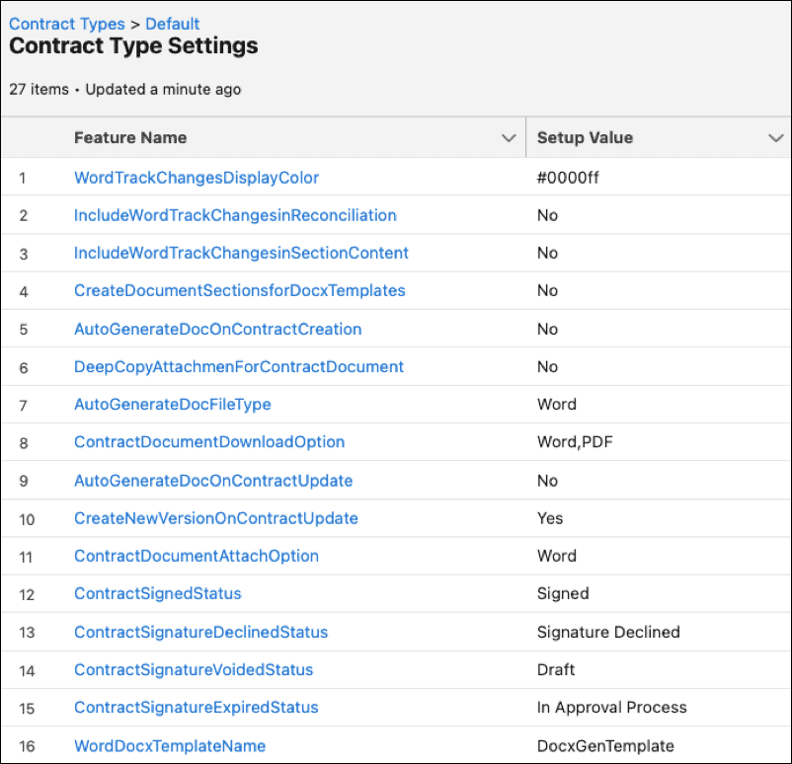

# Lifecycle Configuration

Each contract has a "lifecycle" that it progresses through, based on your compliance requirements. Each implementation of CLM may have a different requirement for what the lifecycle needs to be. Additionally, contract types can have different lifecycles.

Contract State Model and Vlocity Actions

A Contract State Model determines the lifecycle for a specific contract type, controlling which actions and operations are available for certain users at each stage in the lifecycle (based on user profile). A state model lists the contract's valid states and the valid transitions between those "To" and "From" states.

Vlocity Actions control the valid actions and operations for each contract state based on the state model.

Contract Lifecycle Configuration Example

